What Has ESG Achieved So Far?

In the previous courses of this Specialization, we learned that ESG has been around for several years and is increasingly becoming established in organizations worldwide. But do you know what has been achieved so far?
Check Your Understanding
- Myth: Internet searches for ESG-related topics have trebled since 2019.
  - There has been a fivefold growth in internet searches since 2019, reflecting the rising awareness of and interest in ESG topics.
- Fact: Global sustainability investment increased tenfold between 2004 and 2022.
  - Global sustainable investment reached $30 trillion in 2022, a tenfold increase from 2004.
- Fact: There is a positive correlation between ESG performance and value creation.
  - Several studies and reports confirm that there is a positive correlation between ESG performance and value creation.
  - Five ways that ESG creates value, McKinsey Quarterly, November 2019
  - Value Creation: Do sustainable banks outperform?
A Global Problem
The distribution of environmental and social impacts across the globe is not equal. While a small group of countries puts a greater burden on the environment and society, a larger group bears the brunt of the consequences.
These countries experience more pronounced environmental and social impacts due to factors such as poverty, limited access to resources, inadequate infrastructure, and heightened vulnerability to climate change. Urgent action is necessary to promote sustainable development and address social inequities.
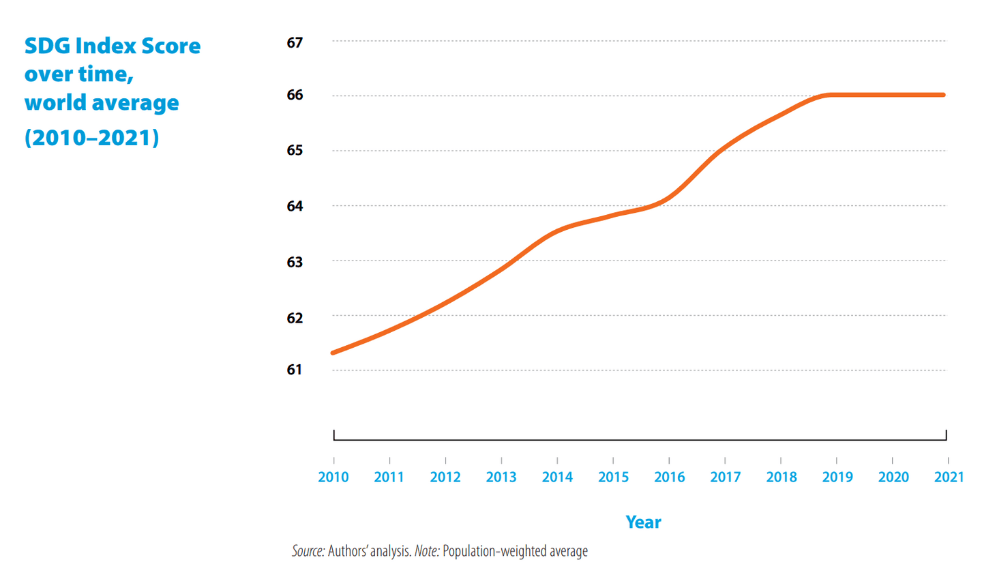
Source: Sustainable Development Report 2022

